BPM HWI
- Business Process
- Issue ::
  - - Manual and Paper-Based Invoice Processing:
    - The accounts payable clerk receives invoices through physical mail, leading to potential delays, misplaced documents, and inefficiencies in processing.
  - - Increased Workload Due to Higher Volume of Invoices :
    - As JSM expands its supplier network to meet growing demand, the number of invoices has significantly increased. However, the process remains unchanged, relying on a single accounts payable clerk, which contributes to further inefficiencies.
  - - Delays in Invoice Verification and Payment Processing:
    - Invoice verification is only conducted once a week in coordination with the purchasing and receiving departments, creating bottlenecks that slow down payment approval.
- Impact ::
- Slower Payment Turnaround: Since verification occurs on a weekly basis, payments are often delayed, potentially harming vendor relationships and leading to penalties. This batch-processing approach means that invoices received early in the week must wait several days before they are even reviewed.
- BPMN
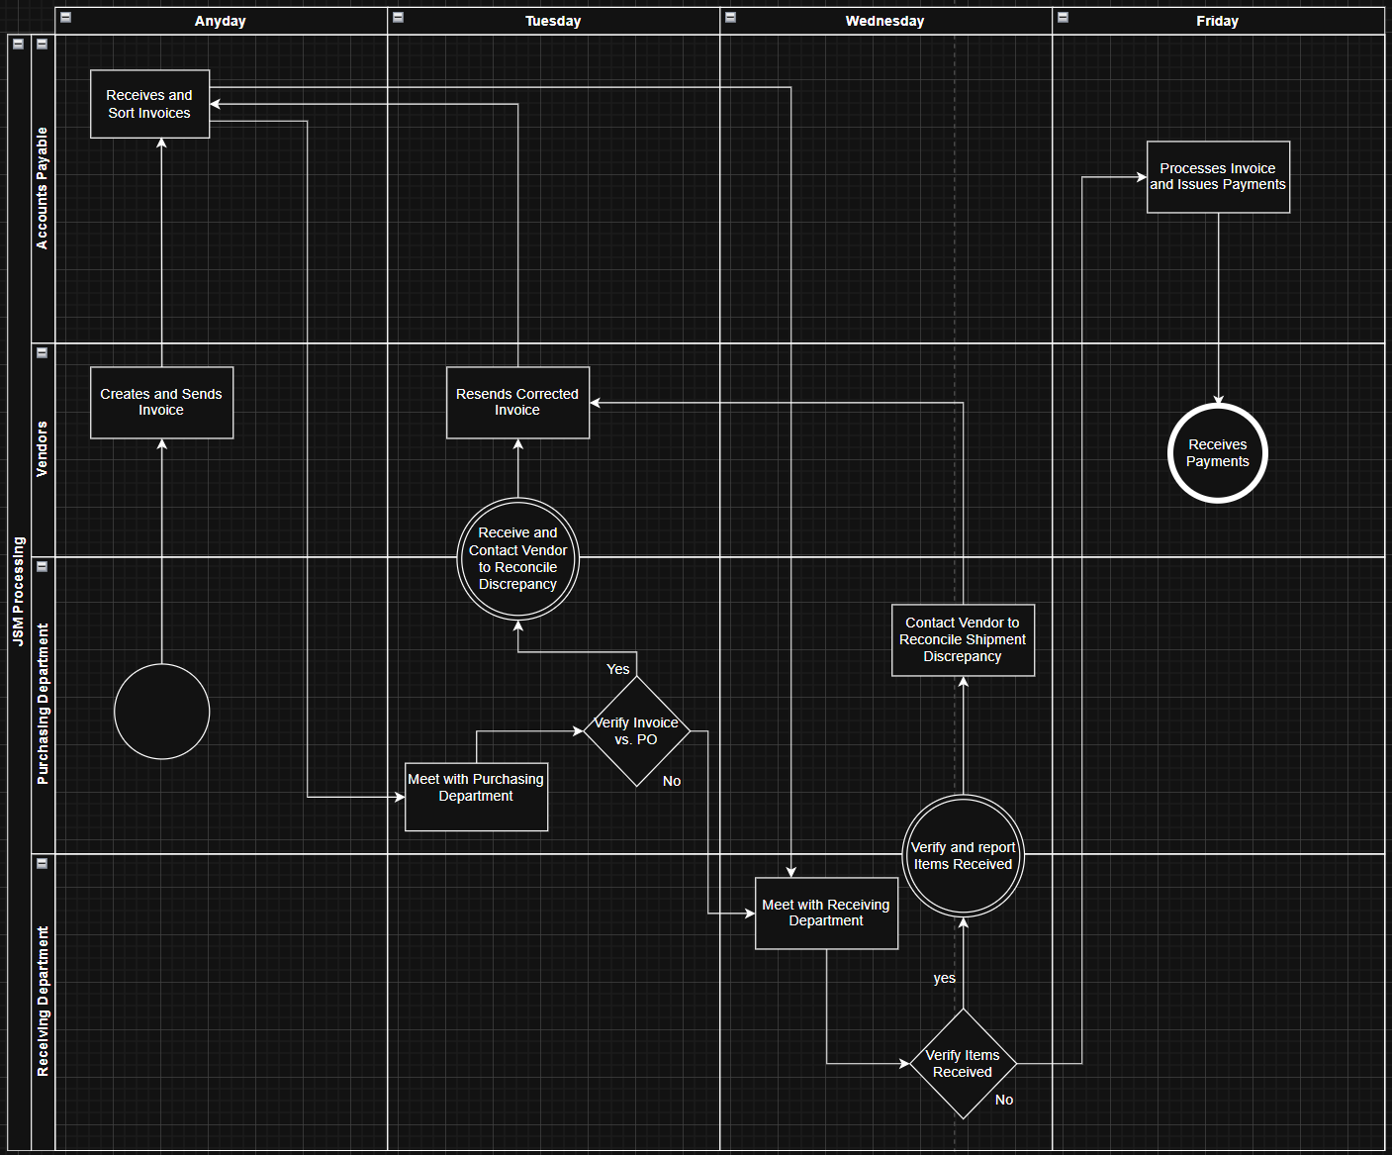
- Metrics
  - - Accuracy Rate in Invoice Verification:
    - Tracks the number of invoices that require corrections due to discrepancies.
  - - Percentage of On-Time Payments:
    - Evaluates how frequently payments are made within the vendor’s agreed-upon timeframe.
  - - Invoice Processing Duration:
    - Measures the time taken from when an invoice is received to when payment is completed.
- Improvements
- Efficient ::
  - - Integrate an Automated Payment System:
    - An ERP system could assist in automatically matching invoices with purchase orders and receipts, reducing manual workload.
  - - Transition to Digital Invoicing:
    - Implementing an electronic invoicing system would reduce dependency on paper, streamline processing, and improve tracking.
- Information System ::
  - – System Benefit:
    - Centralized Dashboard: Provides a clear overview of invoice statuses, ensuring transparency and accountability.
    - Automated Invoice Matching: Reduces manual effort by verifying invoices against purchase orders automatically.
    - Real-Time Alerts: Notifies relevant departments of pending approvals or discrepancies.
  - – Data to Capture: Invoice details, purchase order information, payment due dates, and approval status.

